**1. INTRODUCTION**

**1.1 Overview**

A RFID based library management is a project that manages and stores books information electronically directly into database. The system helps both students and library manager to keep a constant track of all the books available in the library. It allows both the admin and the student to search for the desired book and reduce the manual work.

**1.2 Motivation**

Traditional Library Management requires manual intervention at each and every stage. From borrowing a book to returning, administrator has to update the library database every time. This may increase the risks of more erroneous database entries and updates.

Also, user friendliness gets hampered in traditional library systems as user has to search for the book own his own, thus increasing time constraint. The user may also not find the best book always.

Consider the scenario:

User finds a particular book in traditional library system, but there are higher rated and new versions of the book available in library which the user is unaware of.

**1.3 Problem Definition and Objectives**

Library Management specifies details of books in the Library depending upon several categories like Author-name, Publication, Sales, etc. Manual Library management thus becomes a hectic task for the administrator as he is required to update all the details of

the borrower, dates of issue and receipt manually. This manual management system may lead to errors in updates or deletions in the Library Database, thus decreasing the quality. Automation in library management will lead to less manual intervention, more accuracy in library operations and good quality product for the customer as well as the administrator. Also, automation would help in satisfaction of the user as book searching and choice will become a user-friendly activity.

Objectives are as follows:

* To develop an Android application that will help user to get information about books.
* To develop a web-based application which facilitate the administrator.
* To develop an automated system for entry of data in database.

**1.4 Project Scope & Limitations**

The project aims at easy book retrieval and best book search. Customer has an android application through which he would be able to connect to the library database and search book of his choice. The recommendation system will suggest him a list of books that may be based on the genre, his favorite author and also takes into account the trending books which are been issued in real time. Thus, recommended set is a intersection of trending real time issued books and the choice of the customer.

Book navigation is another feature which is added in application, which helps the user to easily search for the book in the library. On basis of his search, sensors are activated around the library and the book is tracked. Then using certain mathematical formula, the distance is calculated, and shortest route is displayed on the customer’s application.

In traditional library systems, customer has to search for the book on his own, which is hectic sometimes and he may not get the best book available. Also, the manager has to keep track of all the records in the library, calculate fine for returned books, etc. which is time consuming.

In our system, we are automating the basic library operations of issuing and returning books so that there will be minimum manual intervention. The scanners attached on the ceilings as well as the exit doors help in issuing and returning books as well as automatic notifications are sent to customer based on date of return, new books available, etc.

**1.5 Methodologies of Problem solving**

Traditional systems are well organised but the major drawback in them is manual intervention at each and every phase. Our system uses low cost and high efficient RFID tags/ stickers attached to every book and Scanners/ Readers on the ceilings and the exit gateways. The information from the tags gets sensed in real time and through that user can directly issue books, return books which are the base functionalities for any library.

In addition to that, we are providing an android app to the user so that he can directly navigate to the book’s location instead of searching for hours. This app will also notify users about the real time updates, his fine due to the library and recommendations based on his/ her interests. User can check a book’s availability from his home and if available, only then come and fetch it from the library.

For a user to issue or return a book, he will first login to the stand alone base station in the library which will be a web based application. This will allow a single user to issue and return multiple books at the same time due to the unique IDs of the tags. This system thus would better the barcode scanners which don't allow multiple object detection. User can come to the library, search for his favorite books and issue according to his wish very conveniently.

The only manual intervention needed will be of the admin at the end of the day. He can add new books, see the trending books, authors and genres in the insights, see the requested books by the users. Thus, allowing minimum manual intervention and high efficiency and convenience.

# **2. LITERATURE SURVEY**

[1] “Radio Frequency Identification Technology for Advanced Library Management.”, RFID systems usage had become one of the most used technology which improves automation in our modern day life. RFID in libraries had replaced the barcode technology which is the previous technology used in the libraries. RFID technology is for the automation of things and easy authorization of books and RFID technology detects the book which comes into its area of detection but not like the barcode technology using particular line of sight. This project's core idea is about automation of book authorization and prevents the misplacement of books in the respective shelves.

[2] "Design and implementation of library books search and management system using RFID technology.", Radio Frequency Identification technology (RFID) is the key technology to realize the Internet of things. Currently, using RFID to locate objects indoor is a hot topic in the research on the application of RFID. In this paper, we propose an RFID system based on RFID technology and Wi-Fi wireless communication technology. And we design a corresponding handheld device client software to realize a visual book search and management system.

[3] "Design of Internet of Things System for Library Materials Management using UHF RFID.", With RFID applying in library, this paper develops an Internet of Things System for Library Materials Management using Android based UHF mobile reader (Android mobile reader) as its entry to increase the efficiency of library materials management. The functions of the Internet of Things System for Library Materials Management include user identification, inventorying, adding, refreshing, searching, and self-help borrowing & returning library materials.

[4] "Design of books inventory with RFID antenna in library management system.", A 915 MHz printed radio-frequency-identification (RFID) antennas with the characteristics of good gain and omnidirectional beam wave is constructed and evaluated in this study. The objective is to find out their best reading rates for providing effective wireless communications among RFID antenna during the library book inventory process. And an optimal library inventory system which is based on electromagnetic identification (EMID) technology is proposed.

[5] "Internet of Things for library Management System.", The Internet of Things defined as interconnection of uniquely identifiable embedded computing devices within the existing infrastructure. In the near future the world will be overlaid with communication of embedded devices creating a “Smart World”. The world is drenched in the internet and now the Internet of Things is also gaining a lot of attention. But the application of the internet technology in library management is at its infancy.

[6] "RFID based transaction and searching of library books.", In this paper, we have used Radio Frequency Identification (RFID) technology. RFID is a new technology which helps to automate business processes and allows identification of large number of tagged objects like books using radio waves. This paper proposes RFID based Library Management System that would allow fast transaction flow and will make it easy to handle the issue and return of books from the library without the much intervention of manual bookkeeping which benefits by adding properties of traceability and security.

**3.SOFTWARE REQUIREMENTS SPECIFICATION**

**3.1. Assumptions and Dependencies**

The assumptions are: -

* User must have the library application installed on his smartphone
* User must have a good Internet connection
* Sensors must be correctly installed
* Sensors and tags must be resistant to basic wear and tear
* Manager should keep a check on the book tags and sensors on a regular basis

The dependencies are: -

1. UHF- RFID: These tags help in navigating to a book of customer’s choice by activating the sensors.
2. Passive RFID: These are attached to books and help in scanning the books through the exit door
3. Android Studio: We aim to develop an android application, hence we use Android Studio
4. Firebase Realtime Database: This will handle real time issuing and returning of books and also recommendations.
5. Firebase Cloud Messaging: This will help admin to push notifications to the app- holders regarding new book updates, etc.

**3.2. Functional Requirements**

1. Application should send request to the server based on user’s choice
2. Server should quickly respond and give appropriate recommendations
3. Application should help user to navigate to a particular book
4. Application must notify user about return dates, number of books issued and new books available
5. Administrator must be able to monitor, and track records of books issued and returned on a particular day
6. Administrator should be able to get details of the missing and misplaced books

3.2.1. System Feature 1 (Normal user):

3.2.1.1 User Login

Description of feature:

This feature used by the user to login into system. The user required to enter user id and password before they are allowed to enter in the system .The user id and password will be verified and if invalid id or password is there then user is not allowed to enter in the system.

Functional requirements:

● User id is provided when user register itself-The system must allow user with valid id and password to enter the system

● The system performs authorization process which decides what user level can access to.

● The user must be able to logout after user finished using system.

3.2.2 System Feature 2 (Register New User):

Description of feature:

This feature can be performed by user to create account and register itself.

Functional requirements:

● System must be able to verify information.

● System must be able to delete information if information is wrong or invalid.

3.2.3 System Feature 3 (Issue & return book):

Description of feature: This feature allows to directly issue and return

Books.

Functional requirements:

● System must be able to verify information

● System must be able to enter details of various sensor

● System must be able to know the current logged user

**3.3. External Interface Requirements**

3.3.1 User Interfaces:

1. Application must allow the user to view books in the library
2. Application must keep a record of the past issued books of the user
3. Application must provide a register option for new users
4. Existing users can connect to the library server through a login

3.3.2 Hardware Interfaces:

* Raspberry pi
* Ethernet cable
* Connecting wires
* RFID reader
* RFID tags

3.3.3 Software Interfaces:

1.Firebase Database - The Firebase Realtime Database is a cloud-hosted database. Data is stored as JSON and synchronized in Realtime to every connected client. When you build cross-platform apps with our iOS, Android, and JavaScript SDKs, all of your clients share one Realtime Database instance and automatically receive updates with the newest data.

2.Development tools and Programming language- Java SE8 is used to write the whole code for android application and python for connectivity between sensor and OS.

3.3.4 Communication Interfaces:

The communication between the different modules of the system is important since they depend on each other. However, in what way the communication is achieved is not important for the system and is therefore handled by the underlying operating systems for the android application.

**3.4. Nonfunctional Requirements**

* The application must be fast.
* The application must send requests securely.
* The application must receive requests securely.
* The server must be refreshed after every commit.
* The server must be robust.

3.4.1 Performance Requirements:

Server machine should have high speed internet access so that it can handle multiple users at the same time. Another performance requirement is the storage space. Higher storage space means more user and larger workspace per user so higher the storage, better the performance. Performance requirement by the user side is, android application should be developed as a lightweight app so that it can work on almost any platform even with slower internet connections.

3.4.2 Safety Requirements:

If there is extensive damage to a wide portion of the database due to catastrophic failure, such as a disk crash then the recovery method restores a past copy of the database that was backed up to archive storage and reconstructs a more current state by reapplying or redoing the operations of committed transactions from the backed up log, up to the time of failure.

3.4.3 Security Requirements:

Security system need database storage just like many other applications. However, the special requirements of the security mean that system must choose their database partner carefully.

3.4.4 Software Quality Attributes:

● Availability: the system should be available at any time as it is real time monitoring.

● Correctness: the system should give correct prediction of risk of heart attack.

● Maintainability: the system and android app should give correct results of symptoms.

● Usability: the system should consider all possible symptoms for effective risk prediction of heart attack.

**3.5 System Requirements**

3.5.1. Database Requirements:

3.5.1.1. Realtime Database-

The database must be real time to take entry in run time and so the entries from reader are stored directly in it.

3.5.1.2. Always Available-

The data must be readable and writable from the device at any time whether there is an Internet connection or not. Otherwise, users are subject to the availability and quality of a network connection which, as we all know, is often weak or non-existent. So, without a local data store, the user’s experience will be compromised.

3.5.1.3. Secure Data Synchronization-

To store data on the device and in the cloud, the data management platform must provide secure multi-user synchronization. Data on the device and in the cloud should be able to easily and automatically synchronize.

3.5.2. Software Requirements (Platform Choice)

● Operating system (Windows ,Raspbian)

● Android studio

● Firebase server

3.5.3. Hardware Requirements

Usage of CPU, RAM and storage space can vary remarkably based on the user behavior. These hardware recommendations are based on traditional deployments, specifications and may grow or shrink depending on how active the users are.

* UHF- RFID tags
* UHF- RFID Reader
* Passive RFID Tags and Reader
* Raspberry Pi Microcontroller
* Alarm

# **3.6 Analysis Models: SDLC Model to be applied**

* Agile Model:

Agile SDLC model is a combination of iterative and incremental process models which focus on process adaptability and customer satisfaction by rapid delivery of working software product. Agile Methods break the product into small incremental assembles. These builds are provided in iterations. Each iteration typically lasts from one to three weeks. Every iteration involves cross functional teams working simultaneously on various different areas like −

● Planning

● Requirements Analysis

● Design

● Coding

● Unit Testing and

● Acceptance Testing.

Following are the Agile Manifesto principles:

● Individuals and interactions − In Agile development, self-organization and motivation are important, as are interactions like co-location and pair programming.

● Working software − Demo working software is considered the best means of communication with the customers to understand their requirements, instead of just depending on documentation.

● Customer collaboration − As the requirements cannot be gathered completely in the beginning of the project due to various factors, continuous customer interaction is very important to get proper product requirements.

● Responding to change − Agile Development is focus

Advantages of Agile model:

● People and interactions are highlighted rather than process and tools.

● Face-to-face conversation is the best form of communication.

● Continuous attention to technical excellence and good design.

● Regular adaptation to changing circumstances.

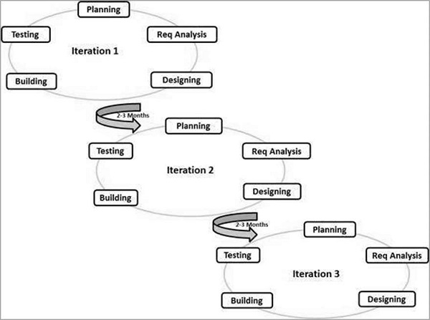● Even late changes in requirements are welcomed.

Fig 3.1 : Agile Model

# **4. SYSTEM DESIGN**

**4.1 System Architecture**

Fig 4.1 : System Architecture

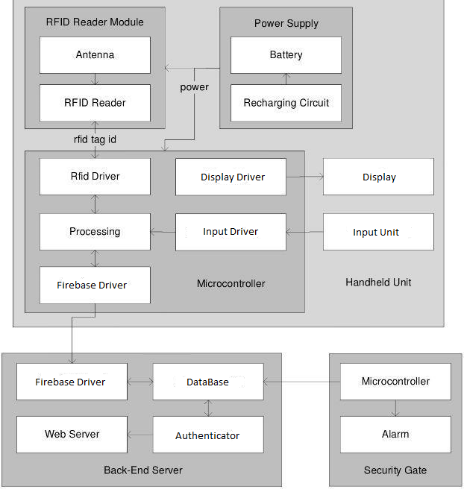

**4.2 Mathematical Model**

Solution set =S

S = {s, e, X, Y, F, DD, NDD}

s - Initial State: User should have smart phone to use the application. RFID tag should be attached on every book in library and suitable sensors installed on the ceiling in library.

e - End state: User finds the required book based on book tracing , or finds a suitable book based on valuable recommendations from the application.

X – Input: User having smart phone enabled with Internet connection.

Y-Output: By signing into the library database, user gets to know about all the books present in the library. Also, he is notified about the new books based on his search and past history. He is notified about the date of return, which books he has borrowed and at which date.

F– Functions/Algorithm: Prediction algorithms like collaborative filtering and Jaccard index coefficient of similarity, Shortest distance finding algorithm like RSSI, etc.

1. – Deterministic Data: RFID tags present on every book, RFID sensors installed and user having the required application installed in his smart-phone.

NDD - Non-Deterministic Data: No Internet connection or failure of Internet connection, failure of Sensors, misplacement of the books, etc.

**4.3 Data Flow Diagram**

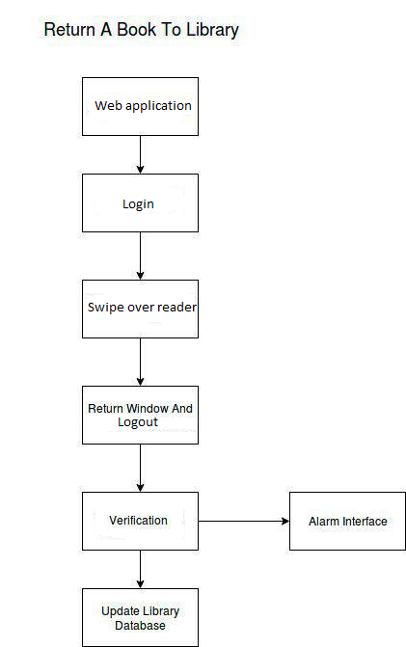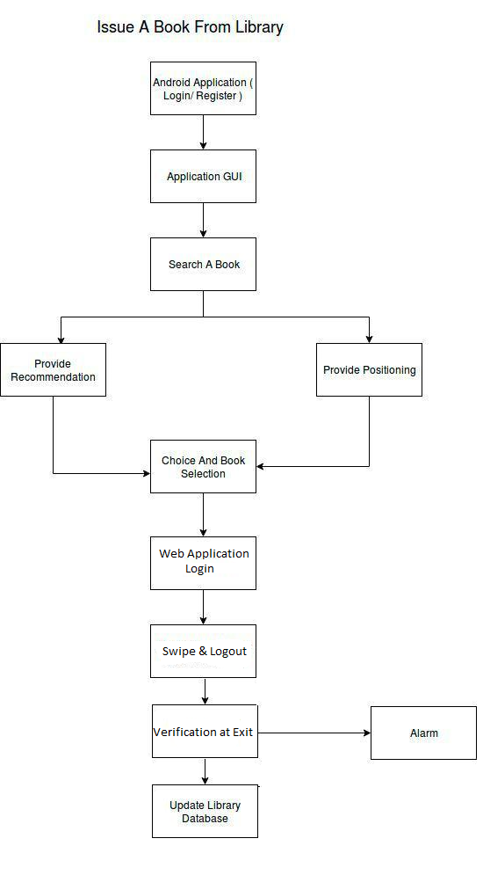

Fig 4.3.2: Data Flow Diagram

**4.4 Entity Relationship Diagrams**

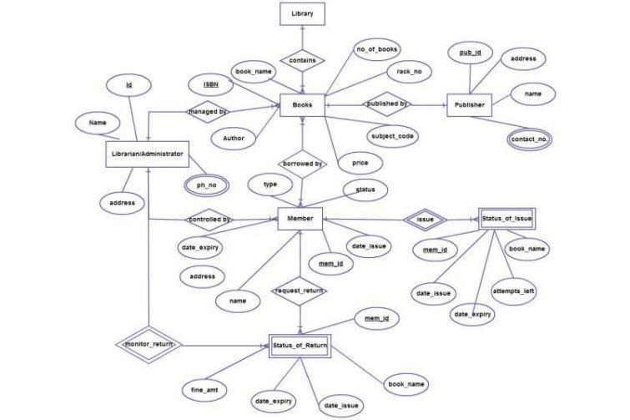

Fig 4.4: ER Diagram

**4.5 UML Diagrams**

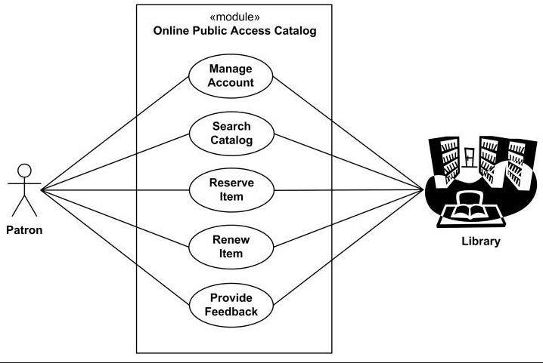4.5.1 Use case Diagram

Fig 4.5.1 : Use Case Diagram

4.5.2 UML Class Diagram

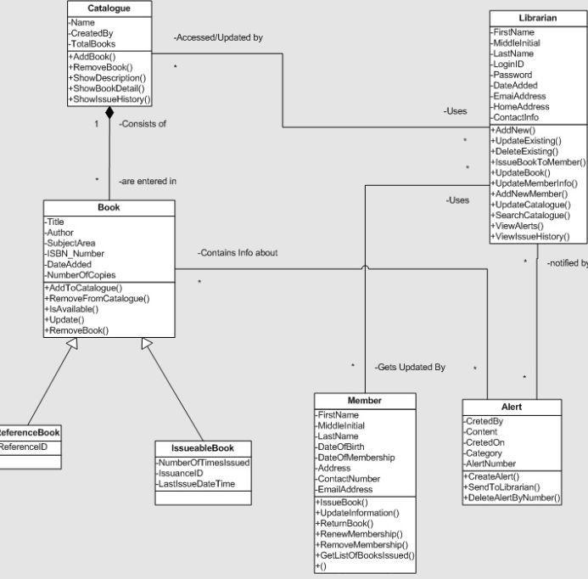

Fig 4.5.2 UML Class Diagram

# **5. PROJECT PLAN**

**5.1 Project Estimate**

5.1.1 Reconciled Estimates

COCOMO Model -

The Constructive Cost Model (COCOMO) is generally used estimation measures of cost, project duration, man power, etc. Like all estimation model, the COCOMO model requires sizing information. The information can be specified in the form of Privacy preserving auditing for secure cloud storage.

● Object Point (OP)

● Function Point (FP)

● Lines of Source Code (KLOC)

For our project, we use the sizing information in the form of Lines of Source code.

Total Lines of source code in our projects, KLOC = 2.5K (Approx.)

Equation: Equation for calculation of effort in person-month for the COCOMO model is:

E = a * (KLOC)^ b

a=2.4, b=1.05, for organic projects. a, b are constants of each category of the software products.

E=Effort in person-months.

Organic project: A software project is said to be an organic type if the team size required is adequately small, the problem is well understood and has been solved in the past and also the team members have a nominal experience regarding the problem.

Estimation of Development Time:

Organic: Tdev = 2.5(Effort) 0.38 Months

Equation for calculation of cost of project, using the COCOMO model is:

Cost = Tdev * 15,000

Where,

C=Cost of project

Tdev = Development time of the project

Efforts Calculated for the application:

Efforts E=2.4(2.5) ^1.05

E = 6.28 person-month

Total of 6.28 person months are required to complete the project successfully.

Estimation of Development Time:

Tdev = 2.5(Effort)^ 0.35 Months

Tdev = 2.5 (6.28) ^ 0.38 Months

Tdev = 5.02 months

Therefore 5.02 months are required to successfully complete the project.

Cost of the project:

Cost = Tdev * 3000

Cost =5.02 * 3000 /-

Cost =15000 /-

The cost required to develop the product= 15000 /-

Observe the convergence or spread among the estimates. Convergence means that you have got a good estimate. Compare the resulting values. If both sets of estimates agree, then your numbers are highly reliable. Otherwise, if widely divergent estimates occur conduct further investigation.

However, as this is a project conducted for Social health purposes the members of the development team are not being paid for creation of the project. Hence, when we conduct the checks to calculate the Reconciled Estimates, they will differ from the formal estimates. This assumption has to be taken in consideration for the Reconciled Estimates.

5.1.2 Project Resources

People

● Project Guide

* Prof. Alka Londhe

● Team Members

* Prashant Gautam
* Hemal Gokhale
* Sharvil Jadhav
* Vineet Job

Software

● Android Studio

● Raspberry Pi Editor

● Putty

● Raspbian OS

● Advanced IP Scanner

● Firebase Database

● Ubuntu / Windows OS

● Python 2.7/ 3.7.1

Hardware

● i3/ i5/ i7 processor-based computer

● Android Phone

● Raspberry Pi board

● MFRC522 Reader

● Passive RFID tags

● Connecting Wires

● Ethernet Cable

Tools and Programming Languages

● Python

● Python firebase

● Java SE8

● Java Machine-Learning bayes-classifier

● Java Firebase

**5.2 Risk Management**

The project risk management plan addresses the process behind risk management and the risk assessment meeting allows the project team to identify, categorize, prioritize, and mitigate or avoid these risks ahead of time. The project risk management plan addresses the process behind risk management and the risk assessment meeting allows the project team to identify, categorize, prioritize, and mitigate or avoid these risks ahead of time. Risk assessment is a step in a risk management procedure. Risk assessment is the determination of quantitative or qualitative value of risk related to a concrete situation and a recognized threat. Risk assessment involves measuring the probability that a risk will become a reality.

5.2.1 Risk Identification

* Product-specific risks - The project plan and software statement of scope are examined to identify any special characteristics of the product that may threaten the project plan.
* Product Size Risks -

• Estimated size in lines of code (LOC)- This system will have an estimated up to 800 lines of code.

• Degree of confidence in estimated size- We are highly confident in our estimated size.

• Estimated size in number of programs, files, and transactions-

1. We estimate 20 programs.

2. We estimate 10 large files for the engine, 10 large files for the user-interface.

3. We estimate 5 or more transactions for the engine, and 10 transactions for the user-interface.

• Percentage deviation in size from average for previous products- We allow for a 20% deviation from average.

• Size of database created or used- The size of the database that we will use will be an estimated 2 tables. The number of fields will vary per table and will have an overall average of 7 fields per table. The number of records in each table will vary with the number of sprites that the user adds to the project, and the number of instances of each sprite that the user creates.

• Number of users- The number of users will be fairly high. There will be one user per instance of the software running, as the software is not client/server or intended for multi-user use

• Amount of reuse of software- Reuse will be very important to get the project started. Proposed system is very simple to reuse (for the most part) and previous programs used to code for with Proposed system will be reviewed and much Proposed system code will be recopied.

• Generic risks - are potential threats to every software product (product size, business impact, customer characteristics, process definition, development environment, technology to be built, staff size and experience)

* Customer Related Risks -

• Does the customer have a solid idea of what is required?

- Yes, the customer has access to both the System Requirements Specification, and the Software Requirements Specification for our project.

• Will the customer agree to spend time in formal requirements gathering meetings to identify project scope?

- Unknown. While the customer will likely participate if asked, the inquiry has not yet been made.

• Is the customer willing to establish rapid communication links with the developer?

- Yes, the customer is available through email, as well as in person, to all project developers.

* Technical Issues -

• Are facilitated application specification techniques used to aid in communication between the customer and the developer?

- The development team will hold frequent meetings directly with the customer. During these meetings the software is discussed and notes are taken for future review.

• Are specific methods used for software analysis?

- Special methods will be used to analyze the software’s progress and quality. These are a series of tests and reviews to ensure the software is up to speed.

• Do you use a specific method for data and architectural design?

- Data and architectural design will be mostly object oriented. This allows for a higher degree data encapsulation and modularity of code.

• Is more than 90 percent of your code written in a high-order language?

- Yes. Code will be written in a combination of Java SE8, Python with a bit of JSON.

• Do you use specific methods for test case design?

- Yes. Test cases will be attempts to check user’s accessibility in-app.

**5.2.2 Risk Analysis**

Risk analysis can be defined in many different ways, and much of the definition depends on how risk analysis relates to other concepts. Risk analysis can be broadly defined to include risk assessment, risk characterization, risk communication, risk management and policy relating to risk in the context of risk concern to individuals, to public and private sector organization and to society at a local, regional, national or global level.

|  |  |  |  |  |
| --- | --- | --- | --- | --- |
| **Risk ID** | **Risk** | **Category** | **Probability** | **Impact** |
| 1 | The user can get the response late | Customer Characteristics | Moderate | Moderate |
| 2 | User can get irrelevant responses | Customer  Characteristics | Low | High |
| 3 | Loss of Internet connection | Development  Environment | High | High |
| 4 | Technology will not meet expectations. | Technology to be built | Low | High |
| 5 | Lack of training on tools | Staff Size and  Experience | Low | High |

Table 5.1 : Risk Analysis

5.2.3 Overview of Risk Mitigation, Monitoring, Management

Risks are potential problems that might affect the successful completion of a software project. Risks involve uncertainty and potential losses. Risk analysis and management are intended to help a software team understand and manage uncertainty during the development process. The important thing is to remember that things can go wrong and to make plans to minimize their impact when they do. The work product is called a Risk Mitigation, Monitoring, and Management Plan (RMMM).

* Risk mitigation (proactive planning for risk avoidance)
* Risk monitoring (assessing whether predicted risks occur or not, ensuring risk aversion steps are being properly applied, collect information for future risk analysis, attempt to determine which risks caused which problems)
* Risk management and contingency planning (actions to be taken in the event that mitigation steps have failed and the risk has become a live problem)

|  |  |  |  |
| --- | --- | --- | --- |
| **Risk ID** | **Risk** | **Response** | **Strategy** |
| 1 | The user can get the response late | Mitigate | 1.Optimize the algorithm  2.Use of strong Internet Connection |
| 2 | User can get irrelevant responses | Mitigate, Monitor | 1.Revise the algorithm |
| 3 | Loss of Internet connection | Mitigate | 1.Use of strong Wi-Fi connectivity |
| 4 | Technology will not meet expectations. | Mitigate | 1.Study of different technologies  2. Use of new technologies |
| 5 | Lack of training on tools | Mitigate | 1. Practicing different tools |

Table 5.2: RMMM

**5.3 PROJECT SCHEDULE**

A PERT Chart is a tool for illustrating workflow dependencies. It shows the order in which tasks must be completed because they depend on each other. PERT stands for Program Evaluation Review Technique

1. Construct a PERT CHART.

* Identify all the necessary tasks in the project.
* Identify dependencies groups or sequences of tasks that must come in a certain order for one reason or another.

2. Use an arrow to indicate tasks that must occur in a certain sequence.

* Construct a basic Timeline with the set deliverables.
* Sort tasks in your PERT Chart by due date either by using Color/ Zones.

|  |  |
| --- | --- |
| **Task Code** | **Project Task** |
| T1 | Discussion on Domain Selection |
| T2 | Discussion on various topics in the selected domain and thrust area identification |
| T3 | Finalizing the topic |
| T4 | Study and discussion on various approaches of data transfer and their feasibility |
| T5 | Discussion about the factors required for the project implementation |

|  |  |
| --- | --- |
| T6 | Selection of technologies for implementing the project |
| T7 | Discussion on SRS |
| T8 | Discussion about Operating Environments |
| T9 | Discussion about Functional and Non-Functional Requirements |
| T10 | SRS Review |
| T11 | Discussion on UML Diagrams. |
| T12 | Discussion on Preparation of Mathematical Model. |
| T13 | Review of Report 1 First Draft. |
| T14 | Report 1 final review |
| T15 | Discussion on the GUI of the project |
| T16 | Discussion about the implementation details of the project |
| T17 | Module wise implementation of the project |
| T18 | Unit Testing of different modules of the project |
| T19 | Integration of different modules of project |
| T20 | Testing the integrated project |
| T21 | Review of report 2 First Draft |
| T22 | Report 2 final review |

Table 5.3: Project Task Set

5.3.2 Task Network

Individual tasks and subtasks have interdependencies based on their sequence. In addition, when more than one person is involved in a software engineering project, it is likely that development activities and tasks will be performed in parallel. When this occurs, concurrent tasks must be coordinated so that they will be complete when later tasks require their work product(s).

A task network, also called an activity network, is a graphic representation of the task flow for a project. It is sometimes used as the mechanism through which task sequence and dependencies are input to an automated project scheduling tool. In its simplest form (used when creating a macroscopic schedule), the task network depicts major software engineering tasks.

Task network for project :

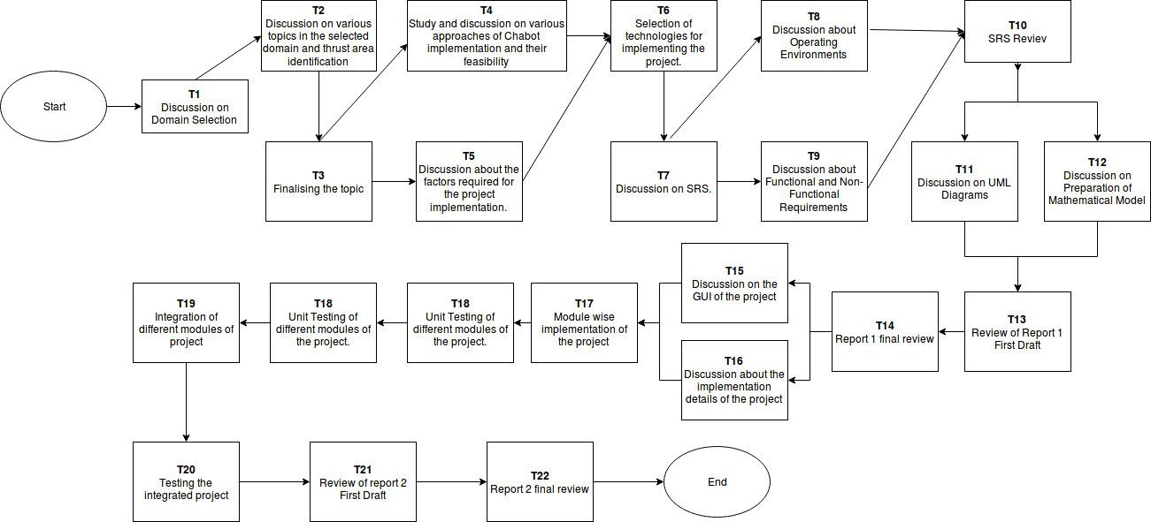

Fig 5.1 :Task network

5.3.3 Timeline Chart:

|  |  |
| --- | --- |
| **Task ID** | **Timelines(Dates)** |
| T1,T2,T3 | 17/06/2018 to 23/06/2018 |
| T4,T5,T6 | 24/06/2018 to 30/6/2018 |
| T7 | 01/07/2018 to 8/07/2018 |
| T8,T9 | 9/07/2018 to 15/07/2018 |
| T10 | 17/07/2018 to 22/07/2018 |
| T11 | 23/07/2018 to 31/07/2018 |
| T12 | 01/08/2018 to 4/08/2018 |
| T13,T14 | 21/08/2018 to 15/09/2018 |
| T15,T16 | 17/09/2018 to 26/09/2018 |
| T17 | 01/01/2019 to 30/01/2019 |
| T18 | 01/02/2019 to 15 /02/2019 |
| T19 | 17/02/2019 to 27/02/2019 |
| T20 | 15/03/2019 to 25/02/2019 |
| T21,T22 | 17/03/2019 to 10/04/2019 |

Table 5.4: Timeline Chart

**5.4 Team Organisation**

5.4.1 Team Structure

|  |  |  |
| --- | --- | --- |
| **Sr. No.** | **Name** | **Roles** |
| 1 | Prof. Alka Londhe | Project Guide |
| 2 | Prashant Gautam | Hardware and Integration Manager |
| 3 | Hemal Gokhale | Developer and Integration Manager |
| 4 | Sharvil Jadhav | Developer and System Designer |
| 5 | Vineet Job | Database and System Designer |

Table 5.5: Team Structure

5.4.2 Management Reporting and Communication

|  |  |
| --- | --- |
| **Team Meeting** | **Discussion Points** |
| Meeting 1 | Discussion on domain knowledge  Discussion on topic  Determination of scope of project  Setting of Objectives  Discussion on research requirement |
| Meeting 2 | Discussion about time ,cost ,budget  Settings of deadlines  Discussion on risks |
| Meeting 3 | Discussion on Software/ Hardware need  Discussion on technology newness |
| Meeting 4 | Discussion On System Design  Discussion On SRS |
| Meeting 5 | Discussion on implemented modules  Discussion on user interface design |
| Meeting 6 | Discussion on testing strategies |

Table 5.6: Management Reporting and Communication

**6. PROJECT IMPLEMENTATION**

**6.1 Overview of Project Modules**

6.1.1 Hardware Module:

Hardware Module consists of various sensors like RFID readers, RFID passive tags a which will help in entering data into database. The sensors are connected vis raspberry pi. The connection between raspberry pi and operating system is done using SSL protocol. Further the data from sensors will get stored at Firebase database using database connectivity.

6.1.2 Software Module:

Software Module is nothing but an android application. The Android application will show the user the details, availability of book fetching from Firebase, which is already been connected to the android application. The Software module further consists of Web based application which can be used by administrator to access the detail of data of book, user, library etc.

**6.2 Tools and Technologies Used**

6.2.1 Raspberry Pi :

The Raspberry Pi is a series of small single-board computers developed in the United Kingdom by the Raspberry Pi Foundation to promote teaching of basic computer science in schools and in developing countries. Processor speed ranges from 700 MHz to 1.4 GHz for the Pi 3 Model B+; on-board memory ranges from 256 MB to 1 GB RAM. Secure Digital (SD) cards in MicroSD form factor are used to store the operating system and program memory. The boards have one to four USB ports. For video output, HDMI and composite video are supported, with a standard 3.5 mm tip-ring-sleeve jack for audio output. Lower-level output is provided by a number of GPIO pins, which support common protocols like I²C

. Specifications:

* SoC: Broadcom BCM2837 (roughly 50% faster than the Pi
* CPU: 1.2 GHZ quad-core ARM Cortex A53 (ARMv8 Instruction Set)
* GPU: Broadcom VideoCore IV @ 400 MHz
* Memory: 1 GB LPDDR2-900 SDRAM
* USB ports: 4
* Network: 10/100 MBPS Ethernet, 802.11n Wireless LAN, Bluetooth 4.0

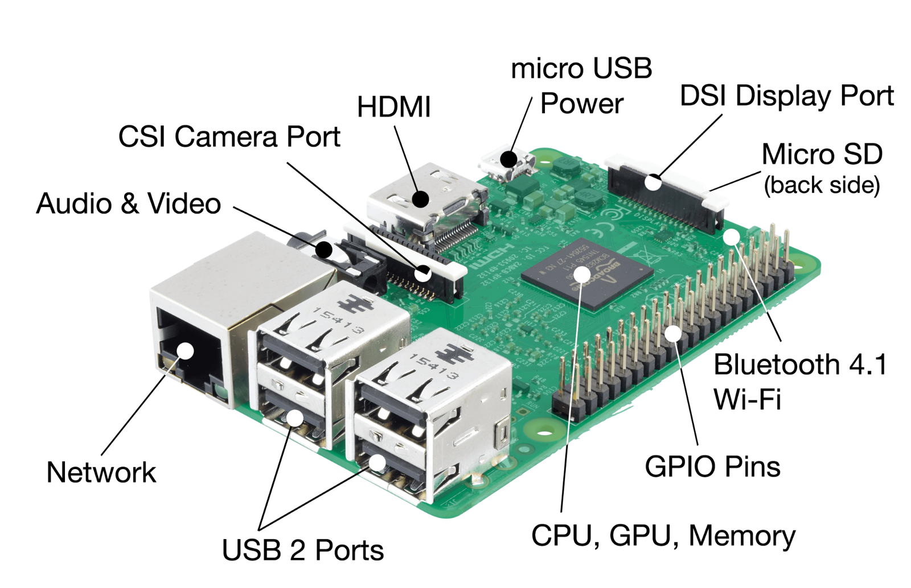Fig 6.1 : Raspberry Pi

6.2.2 Android Studio :

Android Studio is the officialintegrated development environment (IDE) for Google's Android operating system, built on JetBrains' IntelliJ IDEA software and designed specifically for Android development. It is available for download on Windows, macOS and Linux based operating systems. It is a replacement for the Eclipse Android Development Tools (ADT) as the primary IDE for native Android application development. Android Studio supports all the same programming languages of IntelliJ (and CLion) e.g. Java, 

Fig 6.2 : Android Studio

C++, and more with extensions, such as Go; and Android Studio 3.0 or later supports Kotlin and "Java 7 language features and a subset of Java 8 language features that vary by platform version."

Features :

* Gradle-based build support
* Android-specific refactoring and quick fixes
* Lint tools to catch performance, usability, version compatibility and other problems
* ProGuard integration and app-signing capabilities
* Template-based wizards to create common Android designs and components
* A rich layout editor that allows users to drag-and-drop UI components, option to preview layouts on multiple screen configurations
* Support for building Android Wear apps
* Built-in support for Google Cloud Platform, enabling integration with Firebase Cloud Messaging (Earlier 'Google Cloud Messaging') and Google App Engine
* Android Virtual Device (Emulator) to run and debug apps in the Android studio.

6.2.3 Firebase Database:

The Firebase Realtime Database is a cloud-hosted database. Data is stored as JSON and synchronized in Realtime to every connected client. When you build cross-platform apps with our iOS, Android, and JavaScript SDKs, all of your clients share one Realtime Database instance and automatically receive updates with the newest data.

The Firebase Realtime Database lets you build rich, collaborative applications by allowing secure access to the database directly from client-side code. Data is persisted locally, and even while offline, Realtime events continue to fire, giving the end user a responsive experience. When the device regains connection, the Realtime Database synchronizes the local data changes with the remote updates that occurred while the client was offline, merging any conflicts automatically.

The Realtime Database provides a flexible, expression-based rules language, called Firebase Realtime Database Security Rules, to define how your data should be structured and when data can be read from or written to. When integrated with Firebase Authentication, developers can define who has access to what data, and how they can access it.



6.2.4 MFRC522 READER:

The MFRC522 is a highly integrated reader/writer IC for contactless communication at 13.56 MHz .The MFRC522 reader supports ISO/IEC 14443 A/MIFARE and NTAG. The MFRC522’s internal transmitter is able to drive a reader/writer antenna designed to communicate with ISO/IEC 14443 A/MIFARE cards and transponders without additional active circuitry. The receiver module provides a robust and efficient implementation for demodulating and decoding signals from ISO/IEC 14443 A/MIFARE compatible cards and transponders. The digital module manages the complete ISO/IEC 14443 A framing and error detection (parity and CRC) functionality. Signal pulses are equivalent to the heart beat pulses.

### Features

### Typical operating distance in Read/Write mode up to 50 mm depending on the antenna size and tuning

* Highly integrated analog circuitry to demodulate and decode responses
* Buffered output drivers for connecting an antenna with the minimum number of external components Fig 6.3 : MFRC522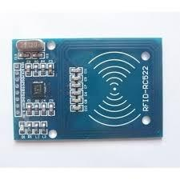

6.2.5 Passive RFID tag :

An RFID tag works by [transmitting and receiving information](http://electronics.howstuffworks.com/gadgets/high-tech-gadgets/rfid1.htm) via an antenna and a microchip — also sometimes called an integrated circuit or IC. The microchip on an RFID reader is written with whatever information the user wants.   
There are two main [types of RFID tags](http://blog.atlasrfidstore.com/active-rfid-vs-passive-rfid):

* Active Tags(battery-operated)
* Passive tags

As the name suggests, battery-operated RFID tags contain an onboard battery as a power supply, whereas a passive RFID tag does not, instead working by using electromagnetic energy transmitted from an RFID reader. Battery-operated RFID tags might also be called active RFID tags. 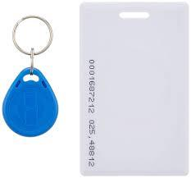

Fig 6.4 RFID tags

Features :

* Works without a battery
* Less expensive to manufacture
* Wear and tear proof

**6.3 Algorithm Details**

6.3.1 Algorithm 1 : Collaborative Filtering

1. Collaborative Filtering is a technique of making automatic predictions based on the current searches been carried out in real- time.
2. Using this technique in the library management system, we can predict what type of book user would be looking for and accordingly he would be recommended.
3. Also, this algorithm will take into account the past history and searches of the user, thus making it predict user’s choice more accurately

6.3.2 Algorithm 2 :Jaccard Index Coefficient Of Similarity

1. Jaccard Indexing is a prediction technique which is based upon the intersection of two entity sets, and the outcome set is recommended.
2. In our system, one set can be considered as the past history or the wishlist of the user. This is user’s personal interests, what types of books he reads, what current scenario is going in the market, etc.
3. The second set is the current real- time purchases going on. This may change according to different seasons ( include exam time, new literatures made available, etc ).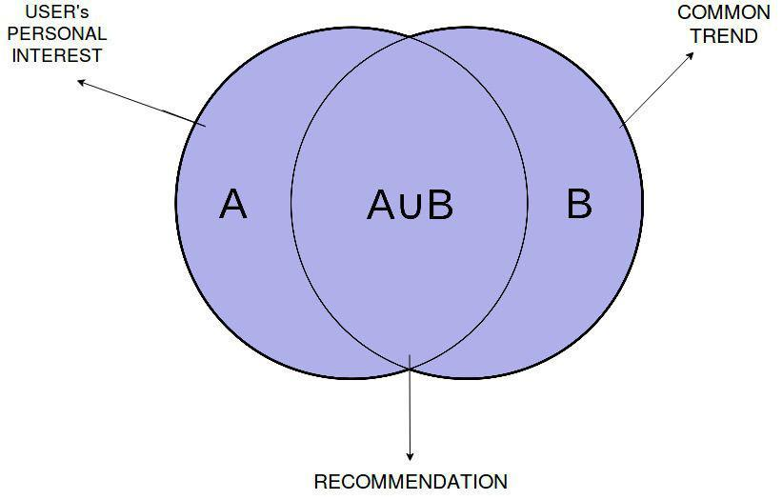

Fig 5.2 Jaccard Index

6.3.2 Algorithm 3 :Relative Received Signal Strength ( RSSI )

1. RSSI technique is a shortest distance finding technique taking into consideration multiple base points, thus giving the shortest route which user may take to reach to his destination.
2. In our system, the scanners installed on the ceilings act as different base points.
3. When user searches for a book, the scanners gets enables and the centroid from all the base points is calculated. The base point nearest to the centroid is considered and specific route gets enabled and user is navigated to the shelf containing the book

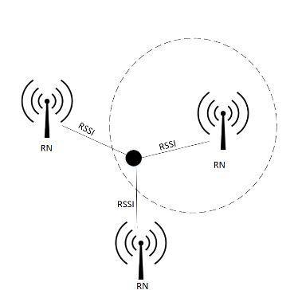

Fig 5.3 ​Relative Received Signal Strength

**7. SOFTWARE TESTING**

**7.1 Type of Testing**

#### Functional Testing:

#### This type of testing ignores the internal parts and focuses only on the output to check if it is as per the requirement or not. It is a Black-box type testing geared to the functional requirements of an application.

#### Graphical User Interface (GUI) Testing

The objective of this GUI testing is to validate the GUI as per the business requirement. The expected GUI of the application is mentioned in the Detailed Design Document and GUI mockup screens. The GUI testing includes the size of the buttons and input field present on the screen, alignment of all text, tables and content in the tables.It also validates the menu of the application, after selecting different menu and menu items, it validates that the page does not fluctuate and the alignment remains same after hovering the mouse on the menu or sub-menu.

#### Integration Testing

Testing of all integrated modules to verify the combined functionality after integration is termed as Integration Testing. Modules are typically code modules, individual applications, client and server applications on a network, etc. This type of testing is especially relevant to client/server and distributed systems.

* Incremental Integration Testing

Incremental Integration Testing is a Bottom-up approach for testing i.e continuous testing of an application when a new functionality is added. Application functionality and modules should be independent enough to test separately. This is done by programmers or by testers.

#### Non-Functional Testing

It is a type of testing for which every organization having a separate team which usually called as Non-Functional Test (NFT) team or Performance team. On-functional testing involves testing of non-functional requirements such as Load Testing, Stress Testing, Security, Volume, Recovery Testing etc. The objective of NFT testing is to ensure whether the response time of software or application is quick enough as per the business requirement. It should not take much time to load any page or system and should sustain during peak load.

#### Performance Testing

This term is often used interchangeably with ‘stress’ and ‘load’ testing. Performance Testing is done to check whether the system meets the performance requirements. Different performance and load tools are used to do this testing.

#### System Testing

Under System Testing technique, the entire system is tested as per the requirements. It is a Black-box type testing that is based on overall requirement specifications and covers all the combined parts of a system.

#### Unit Testing

Testing of an individual software component or module is termed as Unit Testing. It is typically done by the programmer and not by testers, as it requires a detailed knowledge of the internal program design and code. It may also require developing test driver modules or test harnesses.

#### Usability Testing

Under Usability Testing, User-friendliness check is done. Application flow is tested to know if a new user can understand the application easily or not, Proper help documented if a user gets stuck at any point. Basically, system navigation is checked in this testing.

**7.2 Test cases & Test Results**

|  |  |  |  |
| --- | --- | --- | --- |
| **Sr. No** | **Test Cases** | **Expected Output** | **Output from Program** |
| 1. | Enter registered email and correct Password | User gets redirected to Search window | User gets redirected to Search window |
| 2. | Enter Incorrect email and correct Password | Attempts left message will be shown and no next activity launched | Attempts left message will be shown and no next activity launched |
| 3. | Enter Correct email and incorrect Password | Attempts left message will be shown and no next activity launched | Attempts left message will be shown and no next activity launched |
| 4. | Enter Incorrect email and incorrect Password | Attempts left message will be shown and no next activity launched | Attempts left message will be shown and no next activity launched |
| 5. | User scans book with RFID tag attached once | Append book to logged in user’s “issue books” in database | Append book to logged in user’s “issue books” in database |
| 6. | User scans book with RFID tag attached again | Remove book from logged in user’s “issue books” in database | Remove book from logged in user’s “issue books” in database |
| 7. | User walks out of the library without issuing book | Check status from “issue books” and trigger alarm | Check status from “issue books” and trigger alarm |
| 8. | User logs in through web app at base station | Should redirect to user’s landing page | Should redirect to user’s landing page |
| 9. | Only logged in Users should issue or return book | Log in to server first message is displayed | Log in to server first message is displayed |
| 10. | Admin logs into the system | Admin can add books and view insights | Admin can add books and view insights |
| 11. | Admin “goto firebase console” for pushing notifications | Admin can push notifications to users of the Android app from firebase console | Admin can push notifications to users of the Android app from firebase console |

Table 7.1 : Test Cases and Test results

**8. RESULTS**

**8.1 Outcomes**

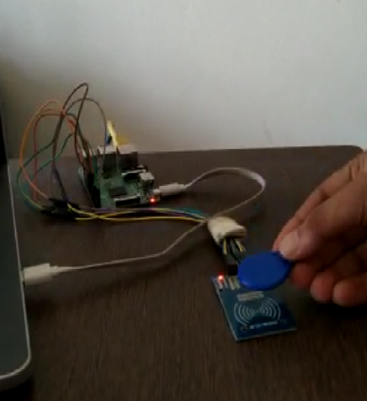

**8.2 Screenshots**

1. **Android Application**

A) Splash Screen and Login

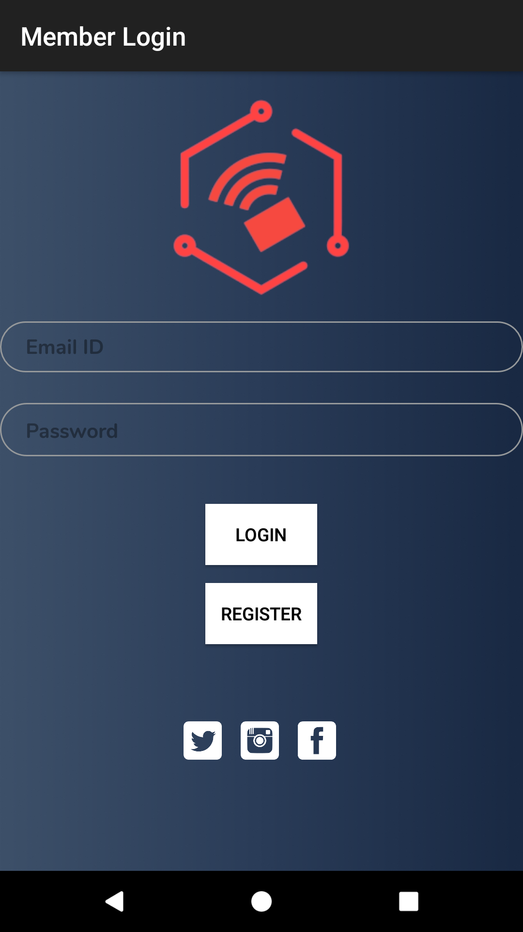

B) Search Window, Navigation view and Book Info Page

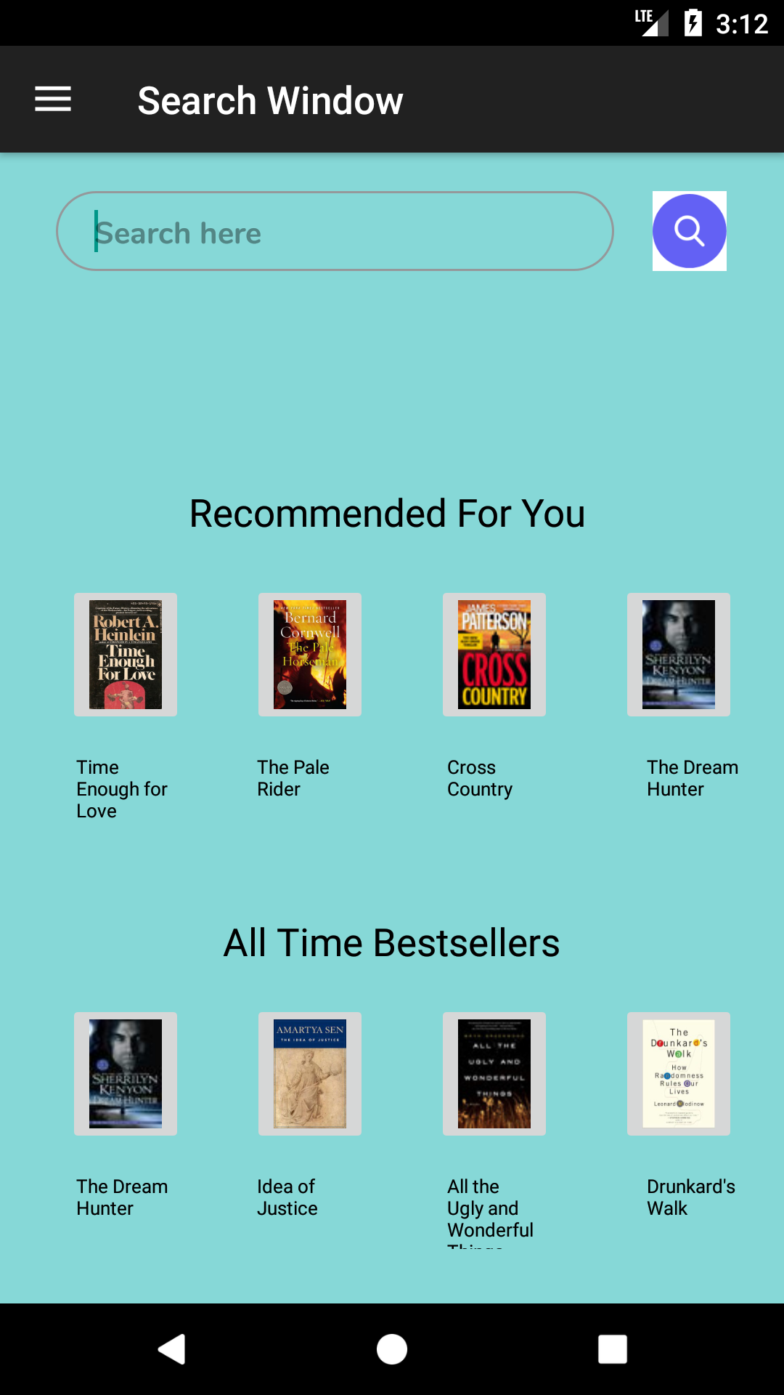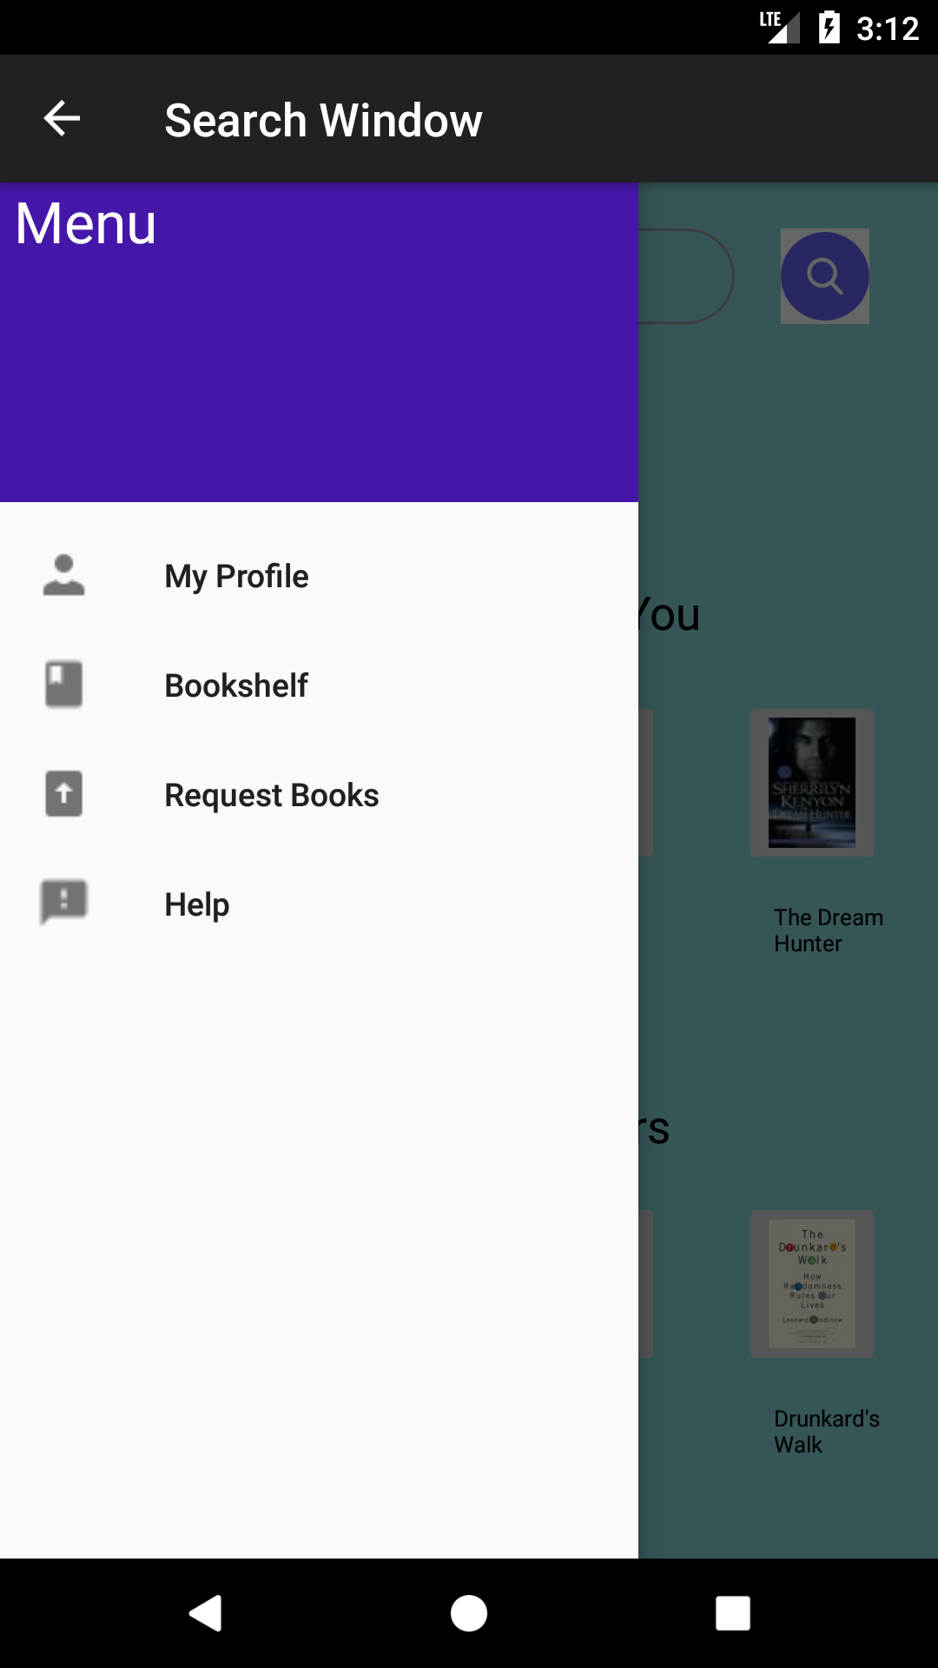

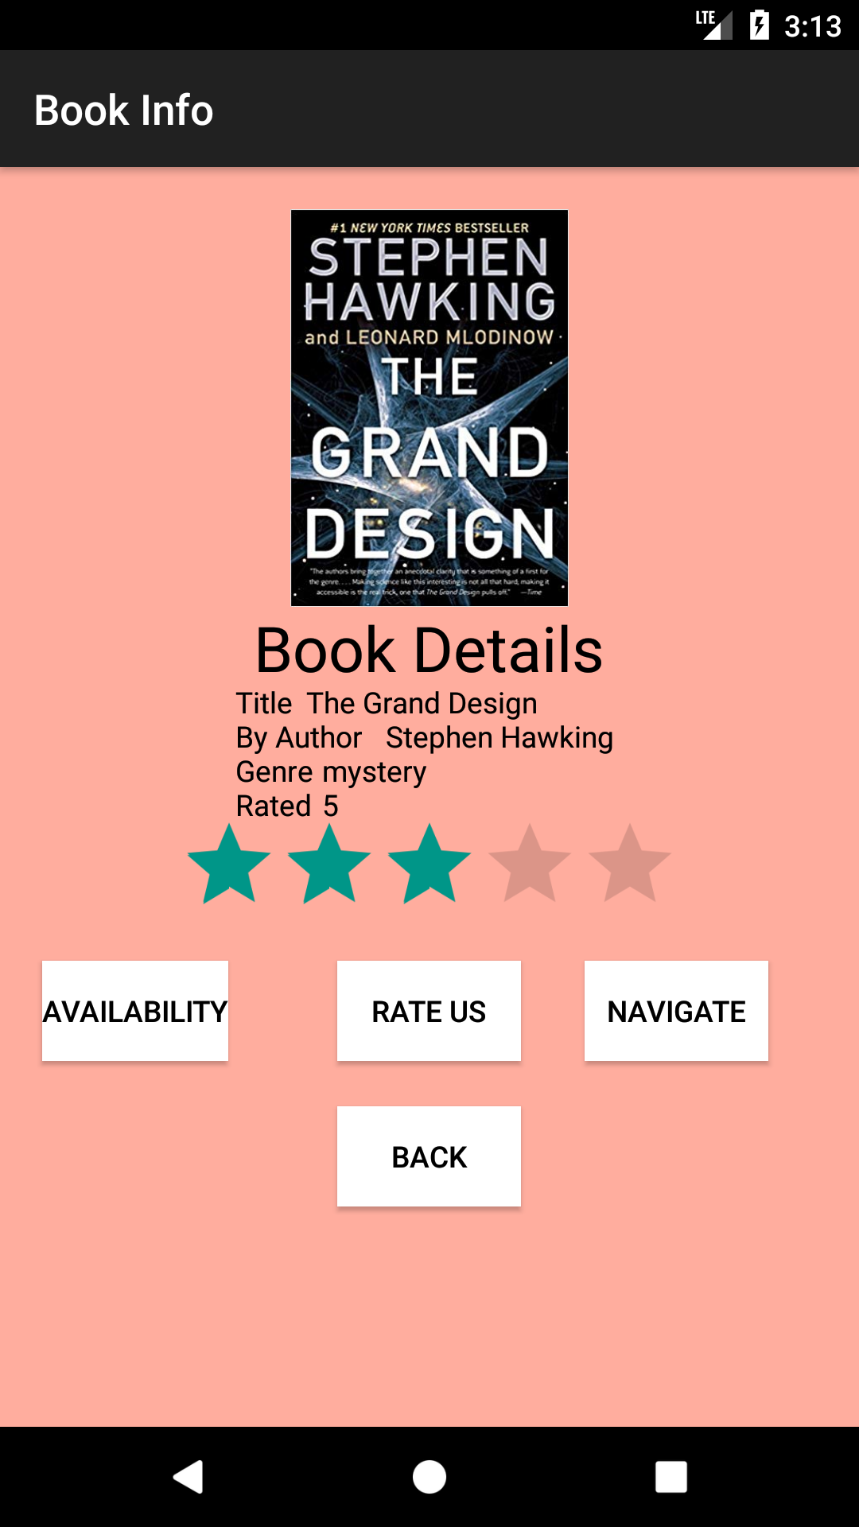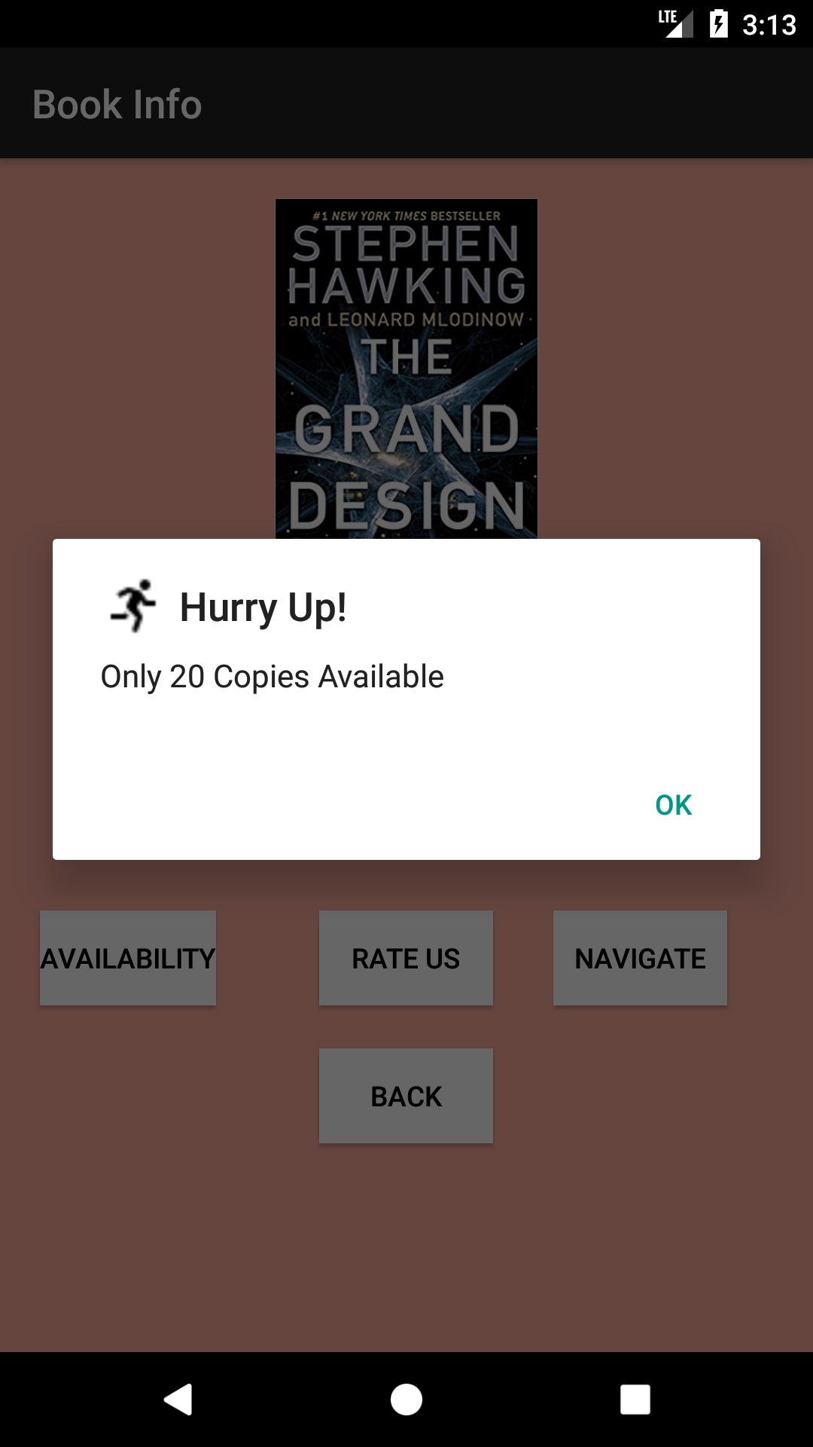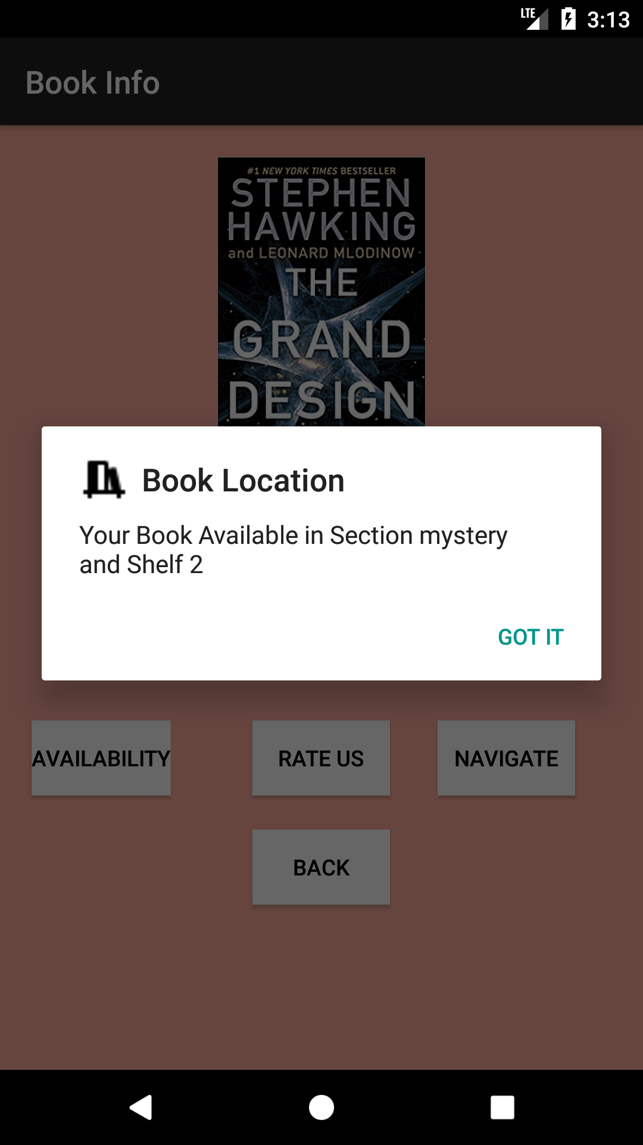

C) Request Books, Help and Issued Books

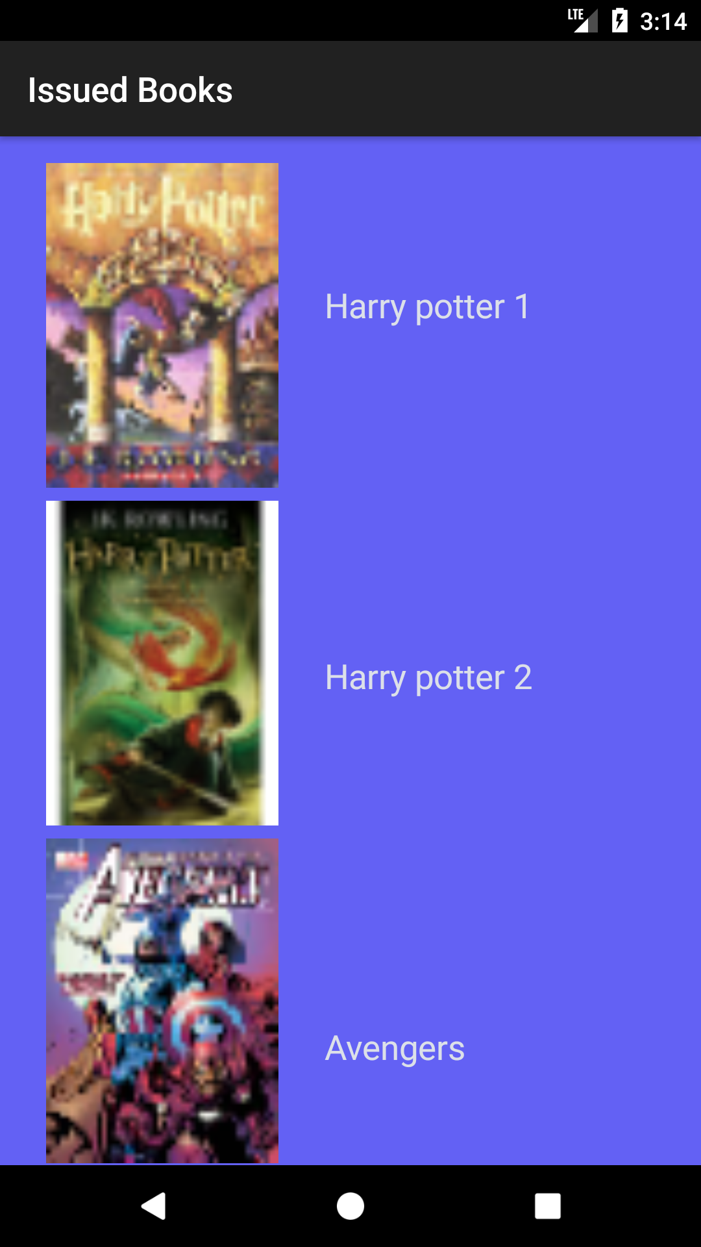 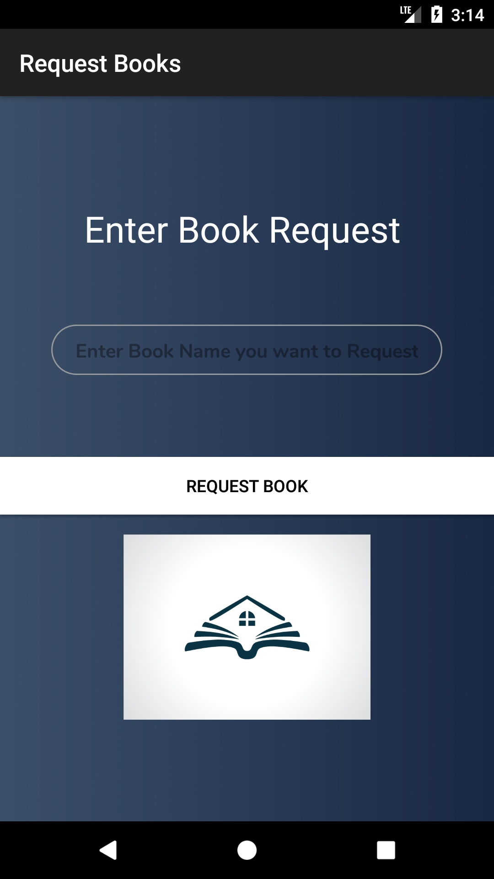

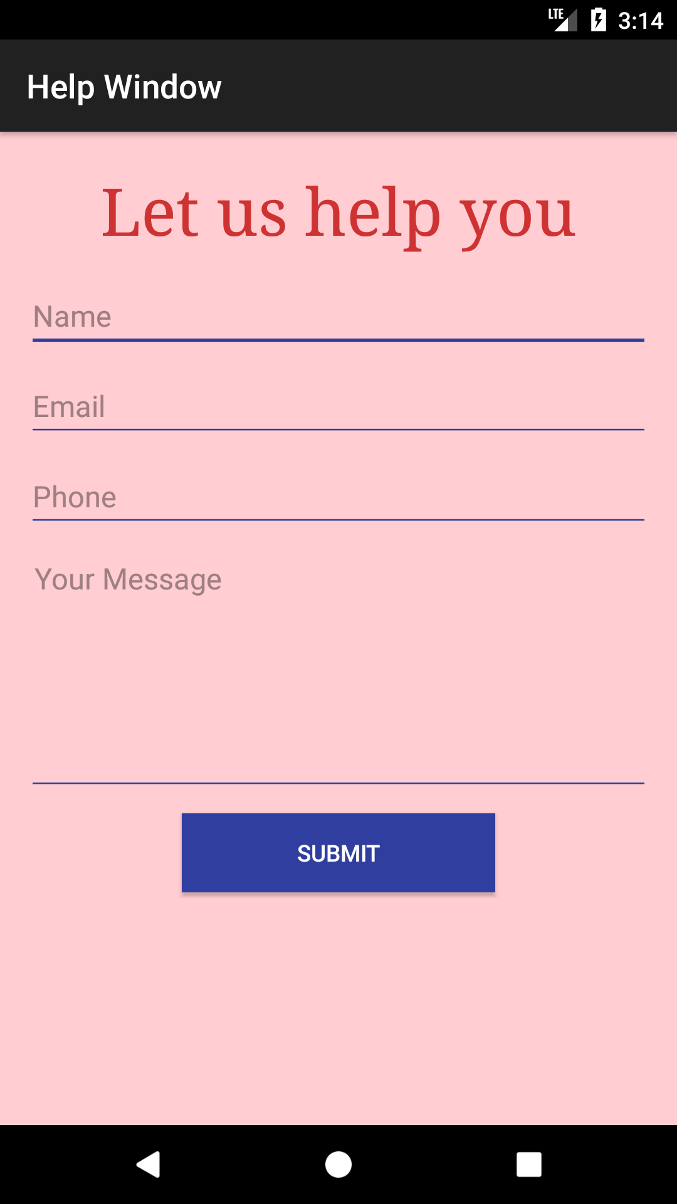

**2 Firebase Database**

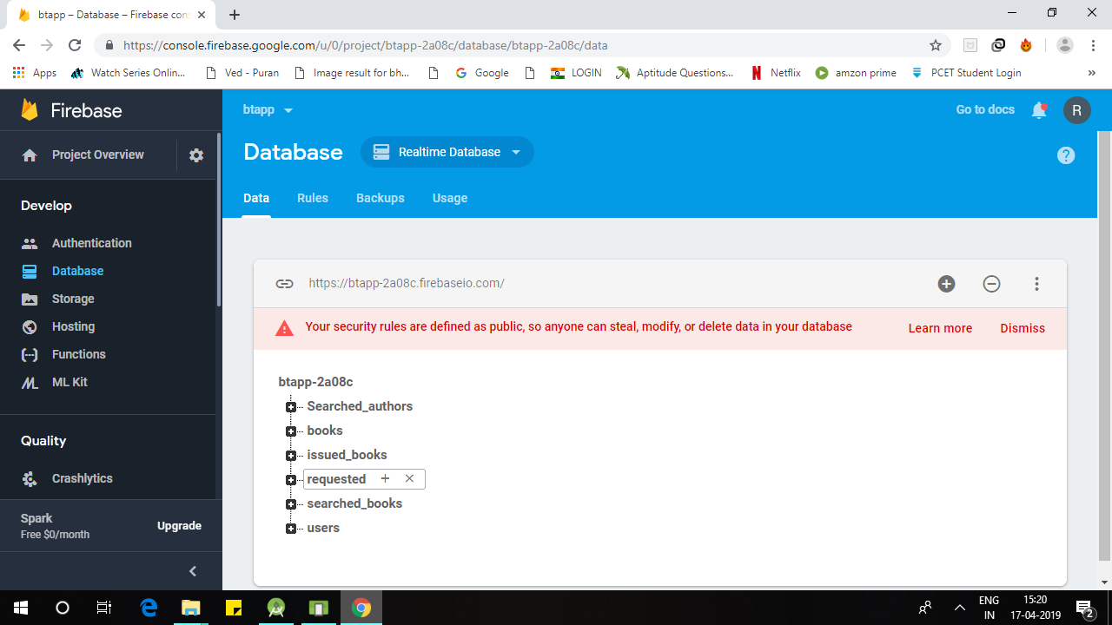

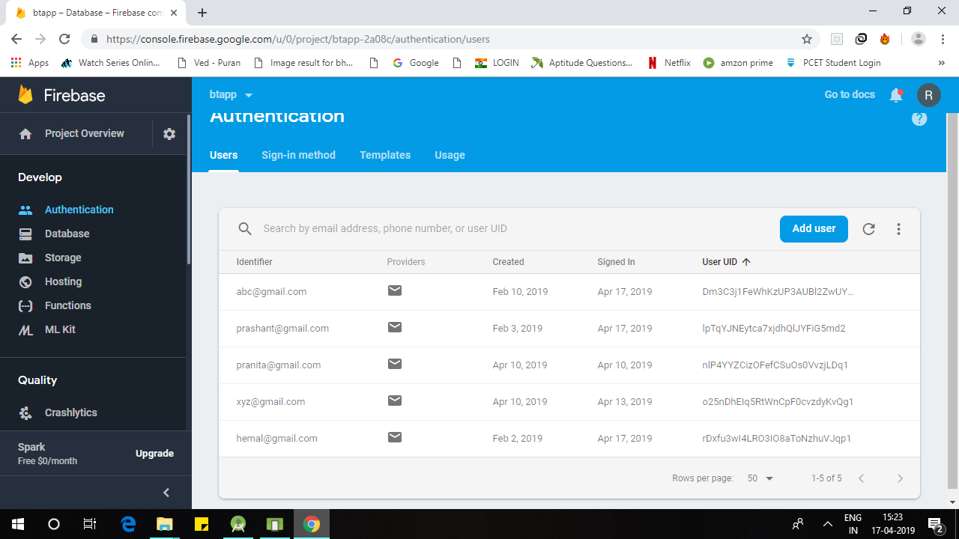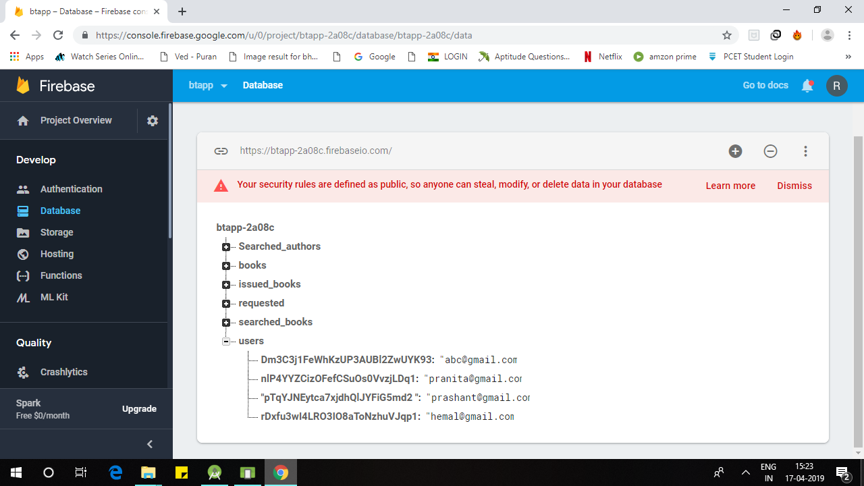

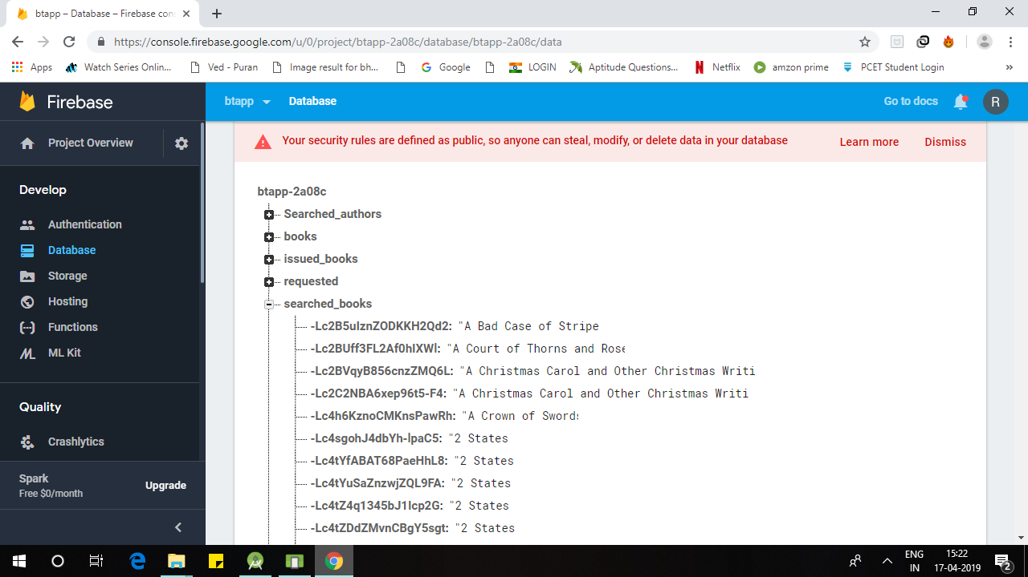

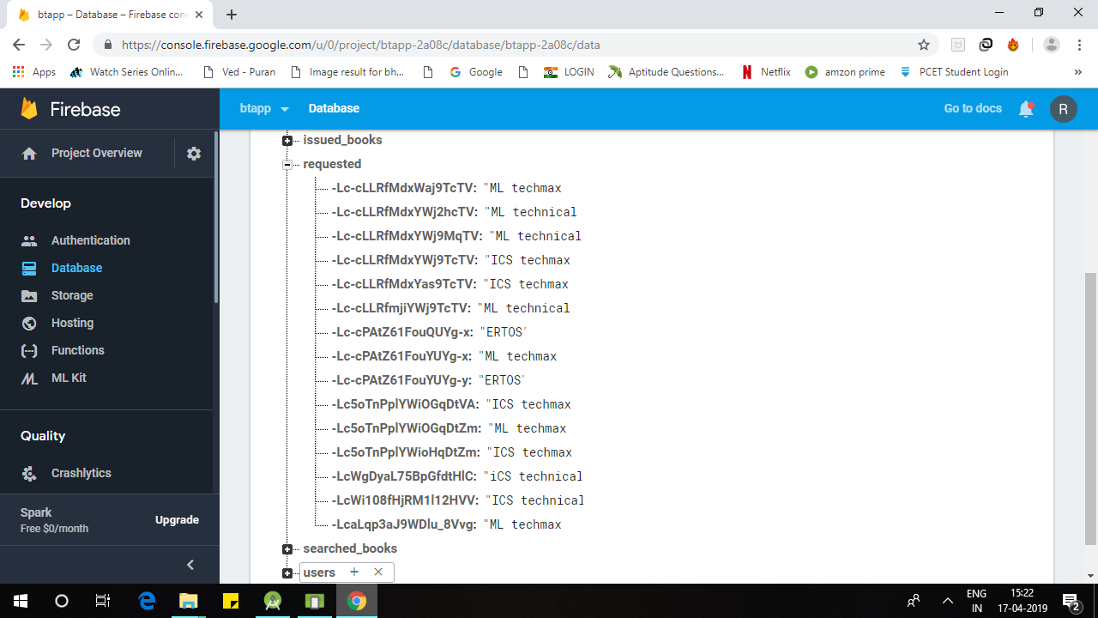

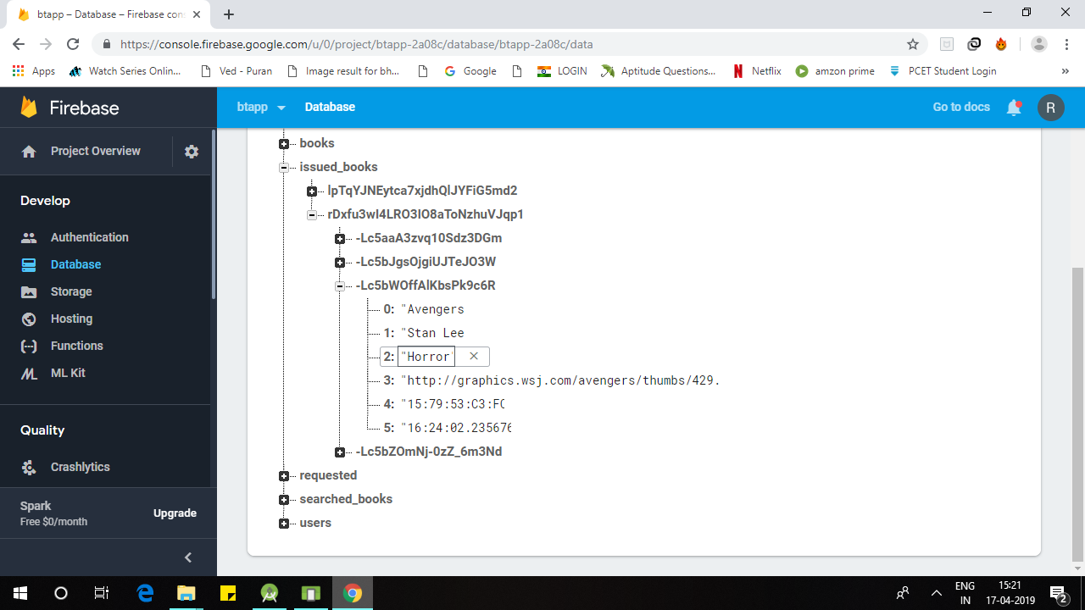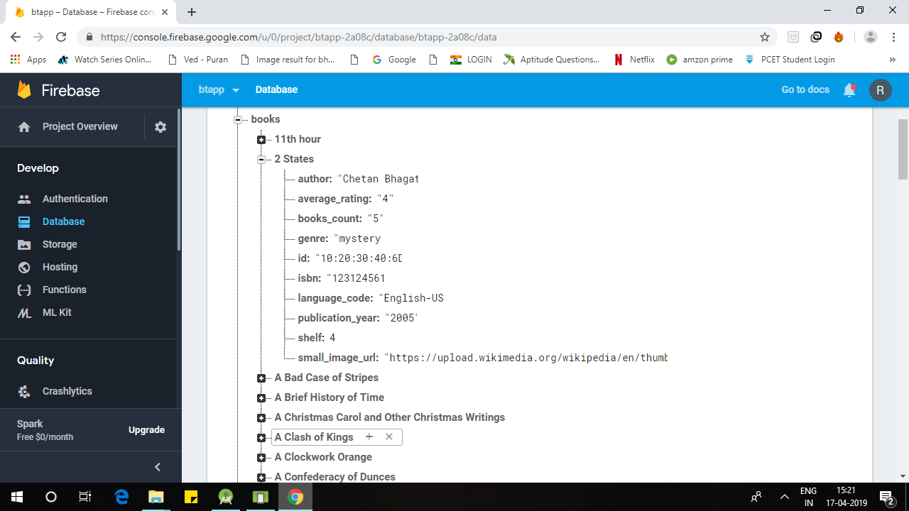

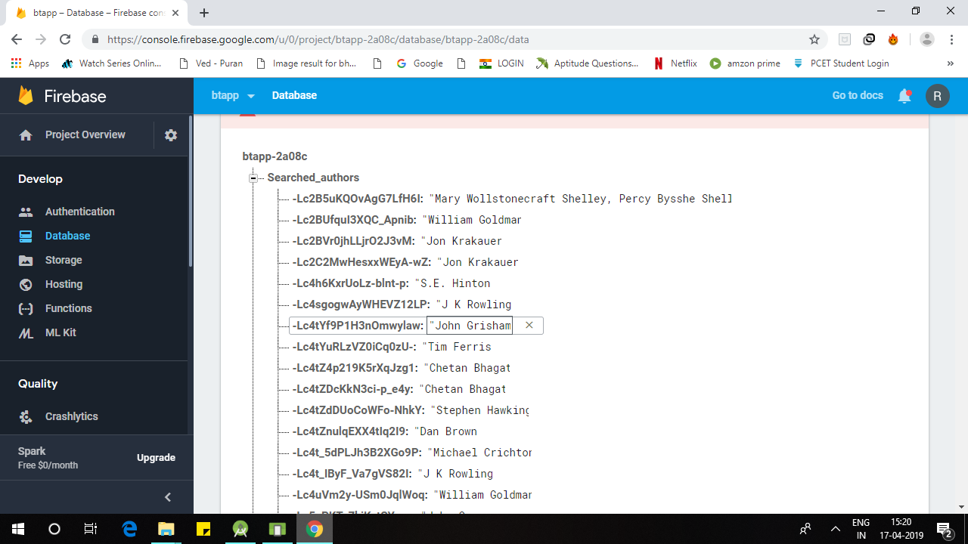

**3 Web application ( Base Station )**

1. Member Login





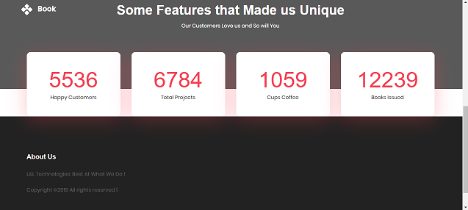

1. Admin Login

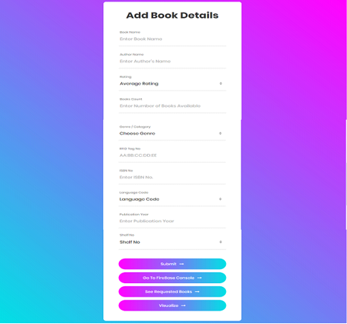

C) Data Visualization & Insights (Graphs)

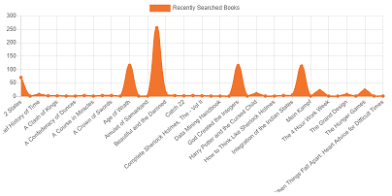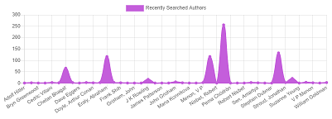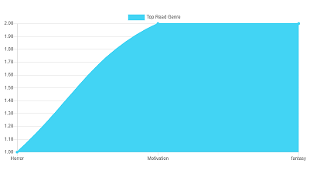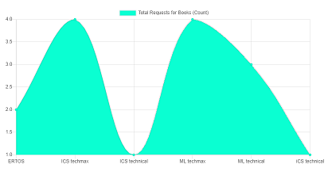

**9.CONCLUSION**

**9.1 Conclusion**

This system will thus provide customer with following benefits:

1. To implement the automated library management along with book recommendation and book tracking
2. To ease customer retrieve the book of his interest and provide necessary recommendations
3. To help administrator monitor the different managerial operations of the library without much intervention

**9.2 Future Work**

In the future, the system can be used to provide following functionalities:

1. Provide exact Positioning of the book placed anywhere in the library
2. Choice of e- book available for an unavailable book
3. Analyze user movements and recommend trending books, etc

**9.3 Applications**

1. This research will allow user to move freely with continuous monitoring system.
2. This will give risk at any time.

**APPENDIX**

**1. Appendix A:**

* NP-Complete problem:

An NP-complete​ ​ decision problem​ is one belonging to both the​ ​ NP​ and the NP-hard complexity classes.any given solution to an NP-complete problem can be verified quickly (in polynomial time), there is no known efficient way to locate a solution in the first place; the most notable characteristic of NP-complete problems is that no fast solution to them is known.

* NP-Hard problem:

A problem is NP-hard if an algorithm for solving it can be translated into one for solving any NP-problem (nondeterministic polynomial time) problem. NP-hard therefore means "at least as hard as any NP-problem," although it might, in fact, be harder.

* P-complete problem:

A problem is assigned to the P (polynomial time) class if there exists at least one algorithm to solve that problem, such that the number of steps of the algorithm is bounded by a polynomial in n, where n is the length of the input.

**2. Appendix B:**

Details of paper publication:

Title of Paper - Automated Library Management System Using RFID

Name of the Journal - IJSERT (International Journal of Engineering Sciences & Research Technology)

Paper Status - Accepted and sent for publication

**Appendix C: Plagiarism Report of project report.**

1. Introduction

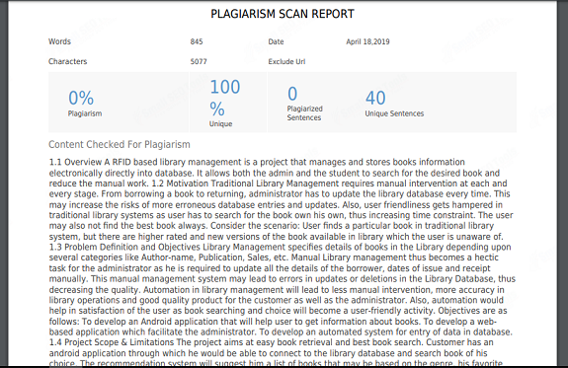

2. Literature Survey

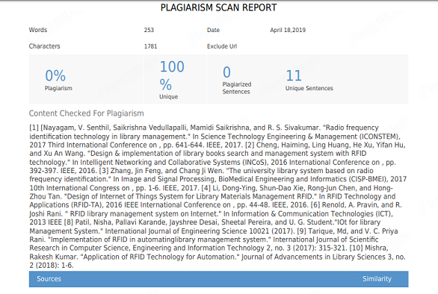

3. Software Requirements Specification

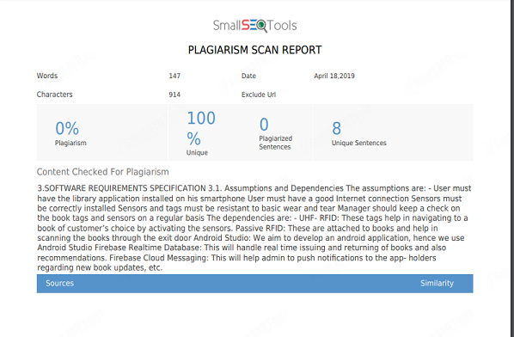

4. System Design

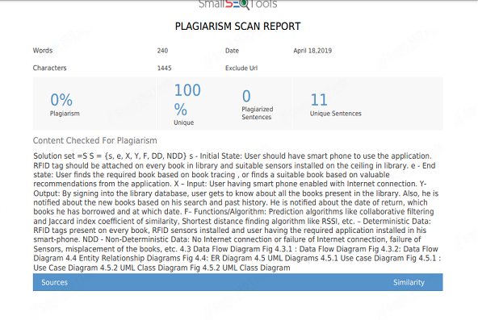

5. Project Plan

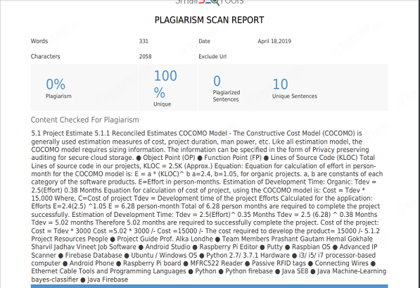

6. Conclusions

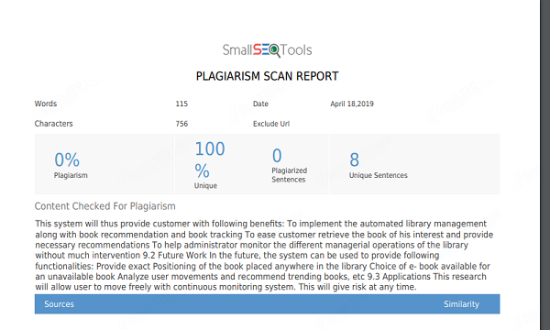

**REFERENCES**

[1] [Nayagam, V. Senthil, Saikrishna Vedullapalli, Mamidi Saikrishna, and R. S. Sivakumar. "Radio frequency identification technology for advanced library management." In ​*Science Technology Engineering & Management (ICONSTEM),* *2017 Third International Conference on​*, pp. 641-644. IEEE, 2017.

[2] Cheng, Haiming, Ling Huang, He Xu, Yifan Hu, and Xu An Wang. "Design and implementation of library books search and management system using RFID technology." In ​ *Intelligent Networking and Collaborative Systems (INCoS), 2016* *International Conference on​*, pp. 392-397. IEEE, 2016.

[3] Zhang, Jin Feng, and Chang Ji Wen. "The university library management system based on radio frequency identification." In ​*Image and Signal Processing,* *BioMedical Engineering and Informatics (CISP-BMEI), 2017 10th International Congress on​*, pp. 1-6. IEEE, 2017.

[4] Li, Dong-Ying, Shun-Dao Xie, Rong-Jun Chen, and Hong-Zhou Tan. "Design of Internet of Things System for Library Materials Management using UHF RFID." In *RFID Technology and Applications (RFID-TA), 2016 IEEE International Conference on​*, pp. 44-48. IEEE, 2016.

[5] Cheng, Ching-Chien, Sung-Tsun Shih, Kong-Xin Cheng, Huang-Kuang Kung, and Chin-Yu Wang. "Design of books inventory with RFID antenna in library management system." In ​*MATEC Web of Conferences​*, vol. 123, p. 00028. EDP Sciences, 2017.

[6] Renold, A. Pravin, and R. Joshi Rani. "An internet based RFID library management system." In ​*Information & Communication Technologies (ICT), 2013 IEEE*

[7] Hassan, Abbas Saleh, and Raoof Talal Hussein. "SIMULATION OF RADIO FREQUENCY IDENTIFICATION BASED LIBRARY MANAGEMENT SYSTEM." *Journal of Engineering and Sustainable Development​*21, no. 4 (2018): 161-170

[8] Patil, Nisha, Pallavi Karande, Jayshree Desai, Sheetal Pereira, and U. G. Student."Internet of Things for library Management System." ​*International Journal of* *Engineering Science​*10021 (2017).

[9] Tarique, Md, and V. C. Priya Rani. "Implementation of

RFID in library management system based on Internet of

Things (IOT)." ​*International Journal of Scientific* *Research*

*in Computer Science, Engineering and Information*

*Technology* 2, no. 3(2017): 315-321.

[10] Mishra, Rakesh Kumar. "Application of RFID Technology in Library Automation." *Journal of Advancements in Library Sciences​*3, no. 2 (2018): 1-6.

[11] Pandey, Jitendra, Syed Imran Ali Kazmi, Muhammad Sohail

Hayat, and Imran Ahmed. "A study on implementation of smart library systems using IoT." In ​*Infocom* *Technologies and Unmanned Systems (Trends and Future Directions)(ICTUS),ernational Conference on​*, pp. 193-197. IEEE, 2017.

[12] Yenurkar, Ganesh K., Rajesh K. Nasare, and Sushil S. Chavhan. "RFID based transaction and searching of library books." In ​*2017 IEEE International Conference* *on Power, Control, Signals and Instrumentation Engineering (ICPCSI)​*, pp.1870-1874. IEEE, 2017.